The Bowel Cancer Screening Programme (BCSP) automatically sends Faecal Immunochemical Test kits (FIT) to people aged 60 – 74 years every 2 years, by post.

Some patients are receiving their BCSP kit around the same time as a Covid-19 self-test kit.
As a result the BCSP helpline is experiencing an increase in helpline calls from confused and worried patients, who do not understand which test is which.

It is likely Track and Trace helpline is also having calls from confused patients, but are unaware of the packing similarities and the issues this is having on patients.

These two home testing kits are packaged very similar, and share similarities within the packages.
Bowel Cancer Screening Test kit | Covid -19 self-test kit
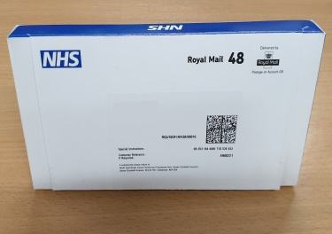 | 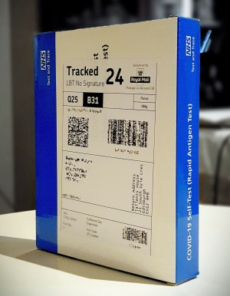
Inside the FIT box | Inside the Covid 19 – self test box (contents could vary slightly)
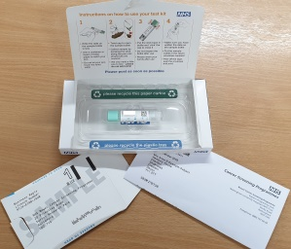 | 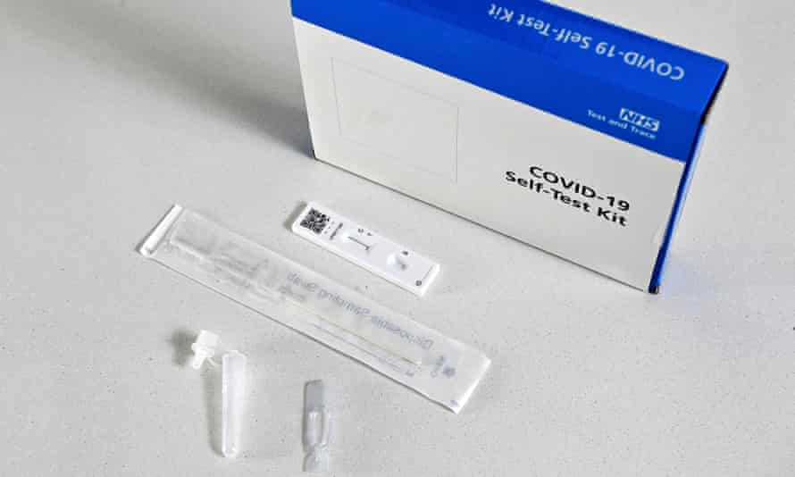
The FIT Bowel Cancer Screening test kit | The Covid – 19 self test lateral flow
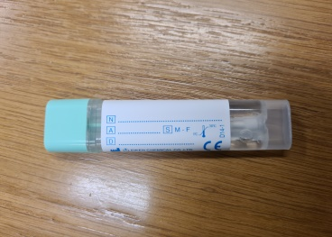 | 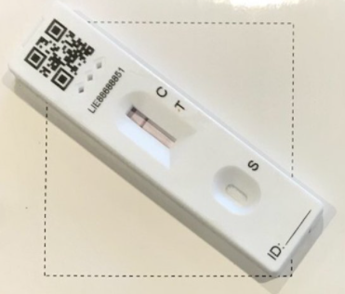
FIT open | Covid swab and kit
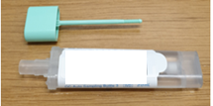 | 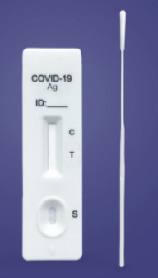
Notable concerns
- The similarities in the packaging are causing confusion to a number of patient’s.
- Many patients have raised that they are anxious when they receive kits, this adds to the confusion despite being labelled.
- Various health providers will be unaware of the similar packages which could create even more confusion as patients seek help.
- Internet searches for images for “Covid test kit” also produce images of the FIT kit.
- Both kit boxes are difficult for anyone with sight problems to distinguish visually, in terms of size and including the contents.
- Boxes arriving close to each other could result in one being discarded, or mixing up contents.

